**Module 9 Student Questions**

## Observation Experiments: Magnetic Moment Motion Impact on Local Magnetic Environment - Guided Inquiry Questions

**Experiment 1**

*Procedure*

* Set up a small grid of compasses separated by 3 - 4 inches in a location where the local magnetic field appears to be largely homogeneous - most likely, the compasses are just aligning with the Earth's magnetic field.
* Randomly place the small magnets in and around the grid of compasses and keep the magnets stationary.

1. What phase of matter would be the closest analogue of this experimental setup?
2. How does the magnetic field appear to vary over different regions of space (i.e. is it more or less homogeneous than before the magnets were added)?
3. Would you expect a sample that is analogous to this experimental setup to have a long or short T2 relaxation time constant? Why?

**Experiment 2**

*Procedure*

* Multiple students should move the magnets around. This motion should include rotating the magnets along with moving the magnets around the region of space where the grid of compasses has been set up.
* Other students observe the response of the compasses.

1. What phase of matter would be the closest analogue of this experimental setup?
2. How does the (time-averaged) magnetic field appear to vary over different regions of space? Does it seem to depend on how fast the magnets are moving? How so?
3. Would you expect a sample that is analogous to this experimental setup to have a longer or shorter T2 relaxation time constant compared with Experiment 1? Why?

## Testing Experiment: Molecular Motion Effect On T2 - Guided Inquiry Questions

Based on the previous observation experiments, Alice and Sayed came up with the following hypothesis to explain how molecular motion may impact the T2 relaxation time:

**Hypothesis:** The faster the molecular motion in the sample, the more homogeneous the spin magnetic environments, and the longer the T2 relaxation time.

1. Design an experiment that can be used to test the hypothesis given above. Include a pulse sequence diagram and explain your choice in the timing values you would use (e.g. 𝜏, TR, etc.)
2. For your designed experiment, what would you predict to see in the resulting time-domain signal and frequency spectrum if the hypothesis above is correct? *Feel free to include rough sketches of your predictions!*
3. Perform your experiment - or look at the provided experimental data that Alice and Sayed collected - and use these results to make a reasonable judgment about the hypothesis.

## How Does Molecular Motion Impact Relaxation Time Constants? - Guided Inquiry Questions

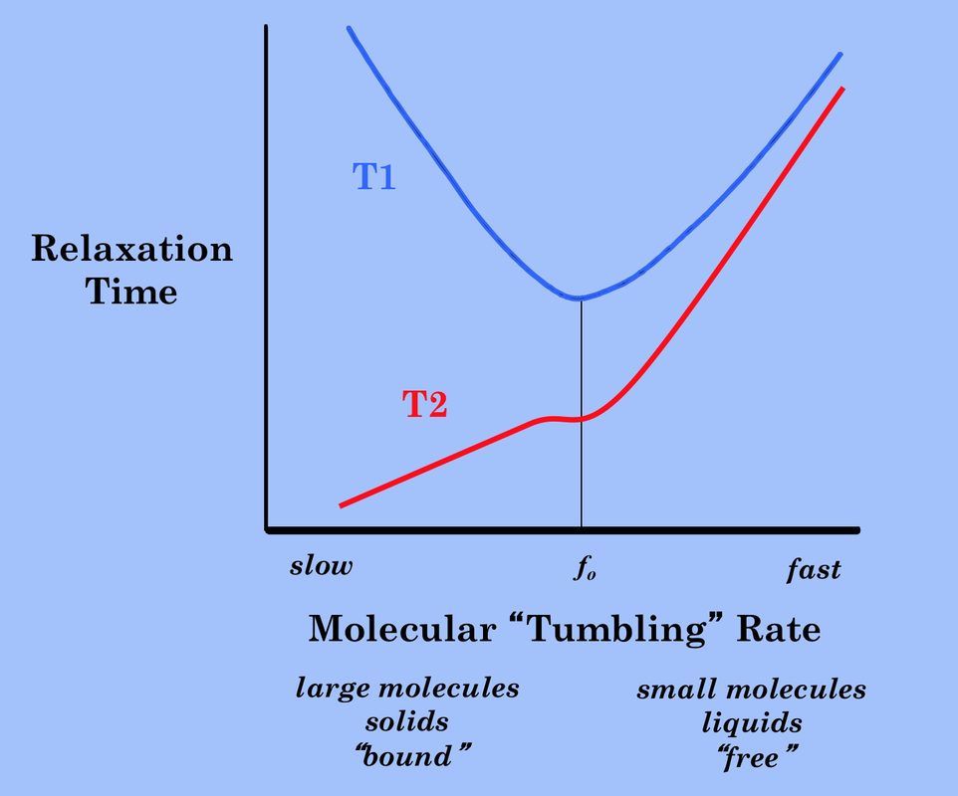

1. Does the plot for the T2 relaxation time versus molecular “tumbling” rate match with your experimental conclusions?
2. Note that the correspondence of T1 in response to molecular “tumbling” rate is not quite as straightforward. It is actually minimal when the tumbling rate is equal to the Larmor frequency. Provide a possible explanation given what we know about resonance (e.g., that using resonance gives the most efficient energy transfer between systems) and the fact that T1 is related to the energy transfer between the environment and the quantum spins.
3. In the ideal MR experiments, we would have the longest possible T2 time - so our signal lasts longer and we get sharper spectral peaks - and the smallest possible T1 time - so we can repeat our experiments faster. Explain, using the diagram above, why solid-state NMR leads to non-ideal MR experiments.

## Reflection Questions

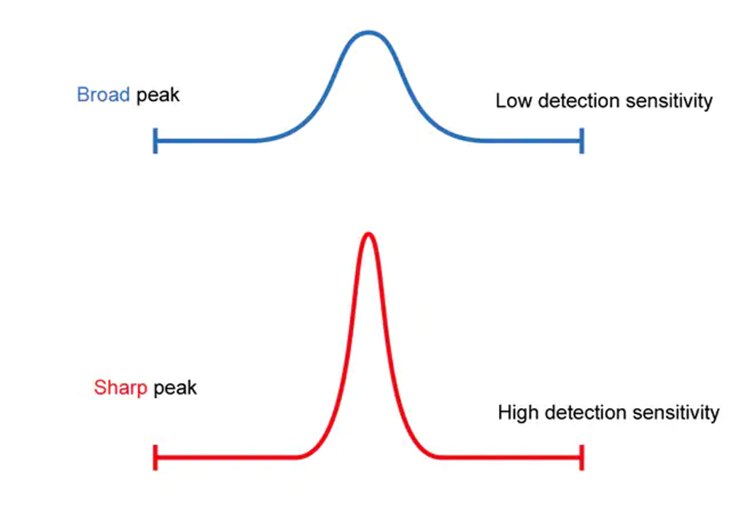

1. In MR experiments, having narrow peaks helps both with detection sensitivity - signal strength - and spectral resolution - how easy it is to see distinct, individual peaks in the frequency spectrum. Both are very important for identifying peaks in the frequency spectrum and having higher resolution in imaging. One common way to get narrower peaks in solid-state NMR is to do [magic angle spinning](https://en.wikipedia.org/wiki/Magic_angle_spinning), where the sample is spun at frequencies up to 130 kHz about an axis that is tilted at the magic angle of 54.74° with respect to the magnetic field. (The magic angle comes from the mathematical formula for the spin-spin coupling causing the short T2, which is beyond the scope of this module.) Why might rotating the sample help narrow the spectral peaks, given what you have learned in this module?

2. From the experiments above, we have seen that faster molecular motion leads to longer and longer T1 and T2 relaxation time constants. So you should presumably get much narrower spectra from doing NMR of gases. However, doing NMR on gases is even less common than on solids. Can you think of some other possible reasons why gases are not as commonly used for NMR experiments? *Hint: Another important factor is detecting the NMR signal, which is directly proportional to the number of spins we have in our sample volume.*

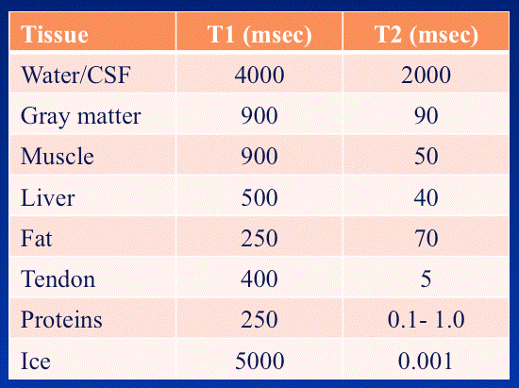

3. Looking at the table above, we see that water and cerebrospinal fluid have the longest T2 time out of the tissues listed. Using what you learned about molecular tumbling rate and its impact on the T2 relaxation time, explain why this makes sense.

4. In MR imaging (MRI), the brightness of the individual voxels (3D pixels) in the 3D image is related to the amount of MR signal one detects in that region of space, along with how quickly that signal decays as the signal is being acquired. Suppose we were doing an 1H MRI of a human head, which has a layer of fat outside the skull and cerebral spinal fluid and gray matter inside. Which of these tissues would show up as the brightest voxels in the image (i.e., have the most signal)? Which of these tissues would show up as the darkest voxels?

## Follow this rubric to assess your work for this module:

| **Scientific Ability** | **Adequate** | **Needs improvement** | **Inadequate** | **Missing** |
| --- | --- | --- | --- | --- |
| **Is able to explain the ways that molecular motion affects the resulting NMR spectra** | All necessary ways that which molecular motion affects NMR spectra have  been explained and written in a comprehensible way. | Some of the ways that molecular motion affects NMR spectra have been explained, but not all. | Some of the explanations contain errors or are incorrect. | No attempt is made to explain the ways that molecular motion affects NMR spectra. |
| **Is able to predict and test how the NMR signal and frequency spectrum will differ from liquid and soft-solid samples** | A prediction is made that  * follows from the hypothesis,  * is distinct from the hypothesis,  * accurately describes the expected outcome of the experiment  A judgment is made, consistent  with the experimental outcome, and assumptions are taken into account. | Prediction follows from the hypothesis, but is flawed, OR  a judgment is made that is consistent with the outcome of the experiment, but assumptions are not taken into account. | A prediction is made, but it is identical to the hypothesis, OR a judgment is made but is not consistent with the outcome of the experiment. | No prediction or test is given. |
| **Is able to identify the challenges of solid-state NMR compared with liquid-state NMR** | Challenges are identified from  all given (or understood)  information and contains no major  flaws. | Challenges are identified correctly, but there is information  missing. | An attempt is made to identify the challenges, but it uses incorrect information or does not agree with the information used. | No attempt is made to identify the challenges of solid-state NMR compared with liquid-state NMR. |